INSTALLATION EXERCISES

EXERCISES 1 → Create an empty virtual machine with the configurations asked

Before starting, in order to have a more complete experience (and for later exercises), it is highly recommended to install the VirtualBox extension pack. You can download it from the official VirtualBox webpage or make a direct download with this link: https://download.virtualbox.org/virtualbox/6.1.16/Oracle_VM_VirtualBox_Extension_Pack-6.1.16.vbox-extpack. This will let us have some more functions such as 3.0 USB support.
This is the process of importation:
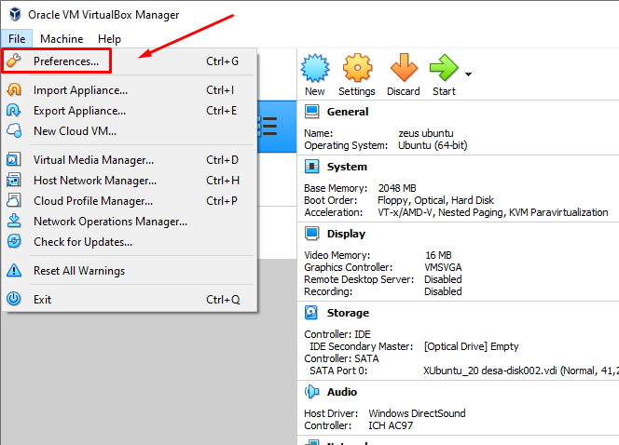

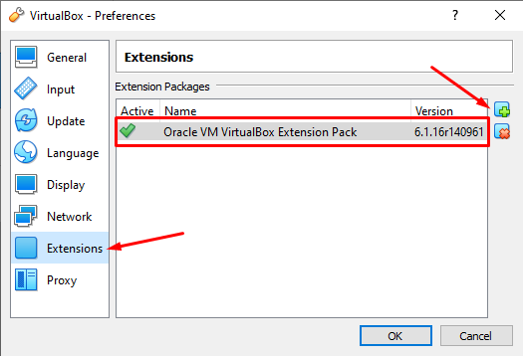
CREATION OF OUR VIRTUAL MACHINE:
First of all, we will need to create our virtual machine for our Windows operating system to work as good as possible. For that, we will click “New” and we will write the name for our virtual machine.
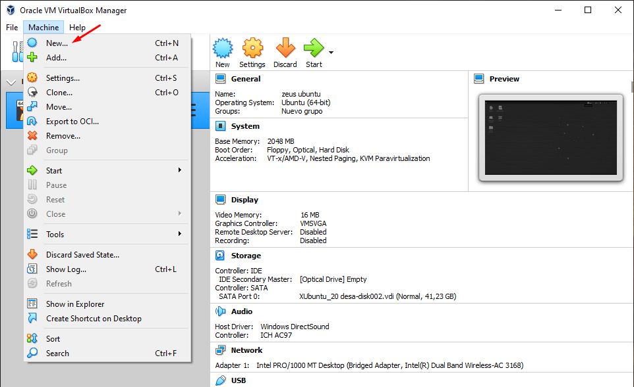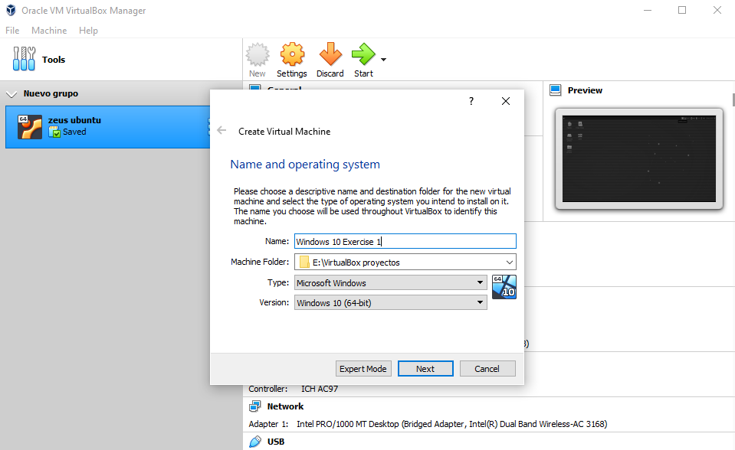

Then we need to set our memory size: 2GB of RAM (2048MB) and 2 hard drives. This first hard drive will have 50GB and will be configured as “Dynamic”. This option will be better for our physical computer, as it means it will use the memory assigned just when it is necessary, it won’t take directly the 50GB for an empty disk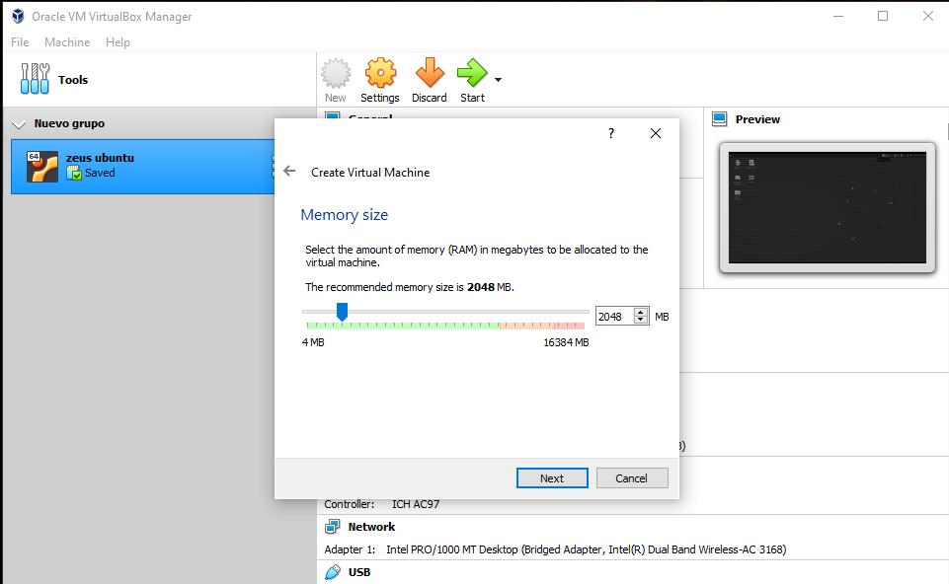.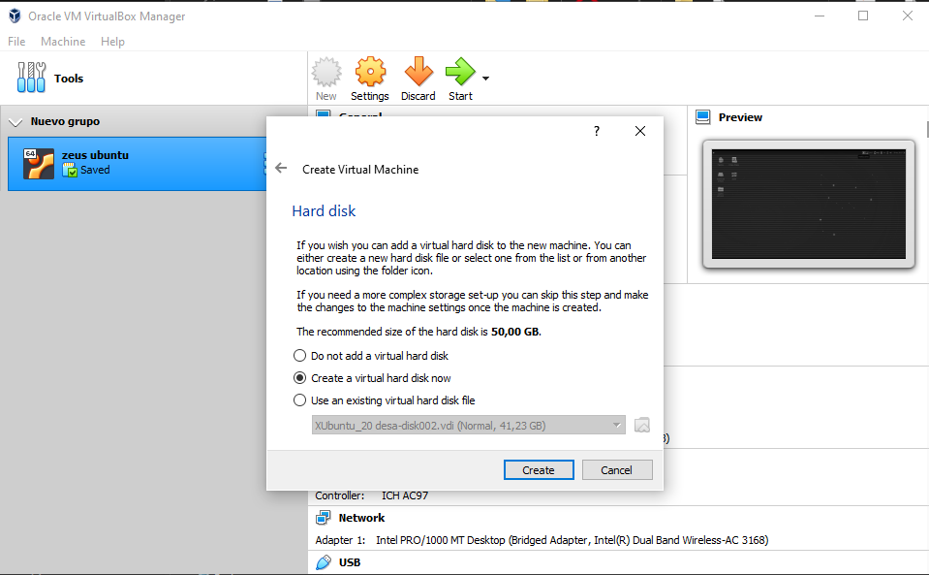
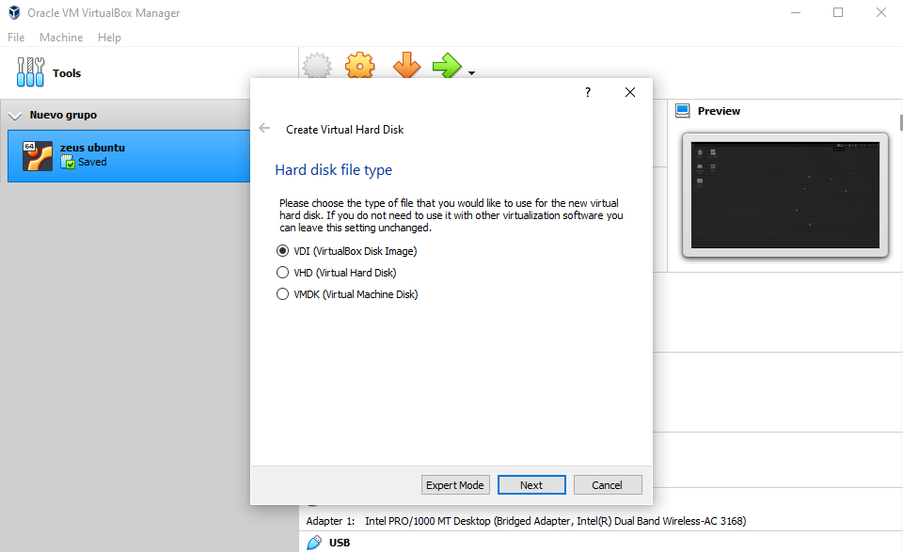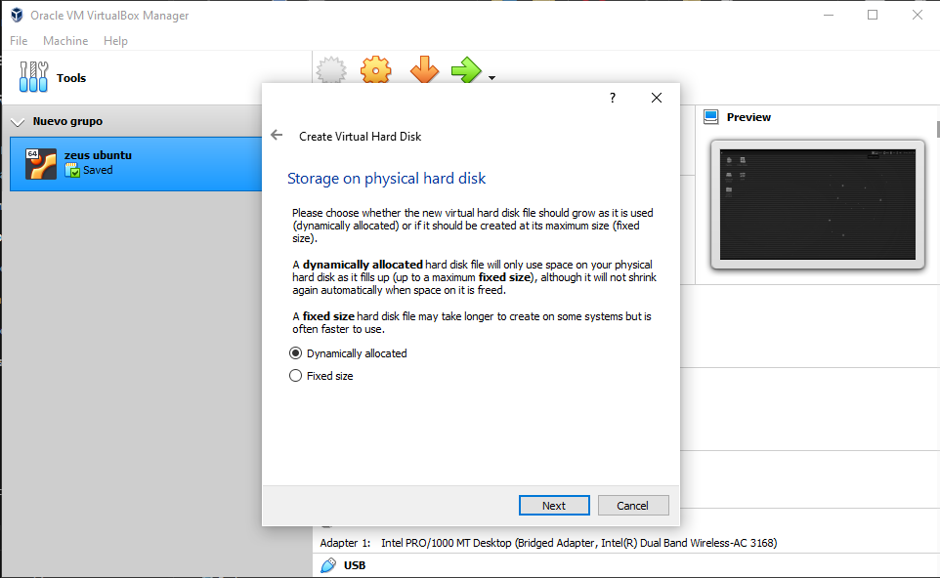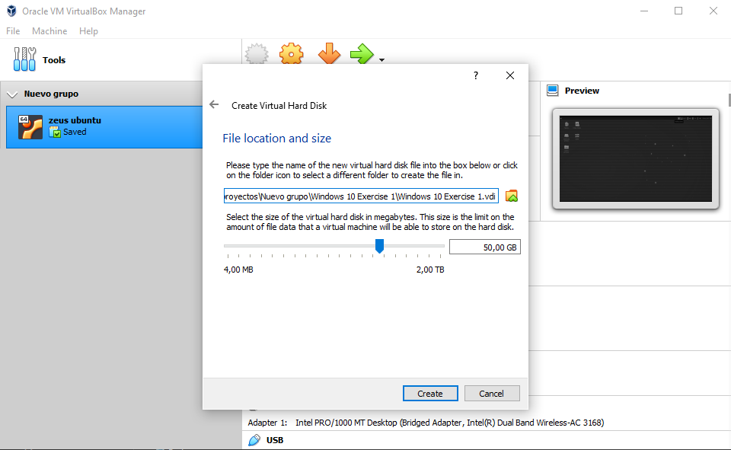

Now we need to create our second hard drive, so once the virtual machine is ready, we will click “settings” and do the following:

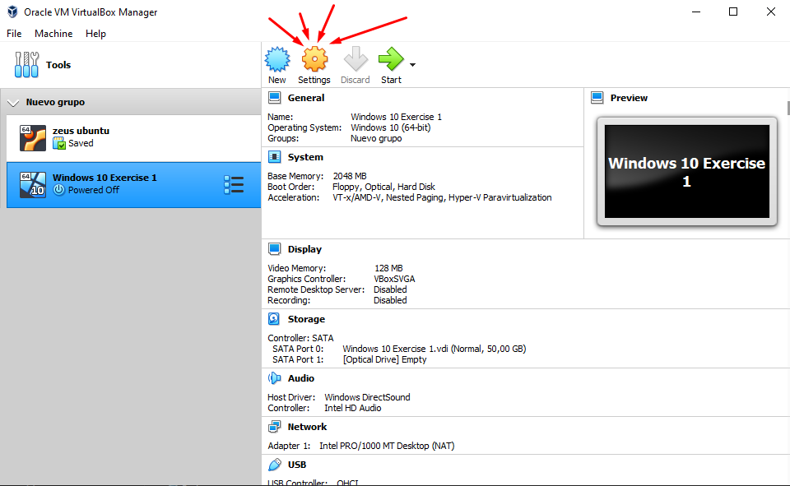

We will go to “Storage” and click the pointed out icon. We will create a new hard drive, but this time of 30GB. The creation process is the same as the previous one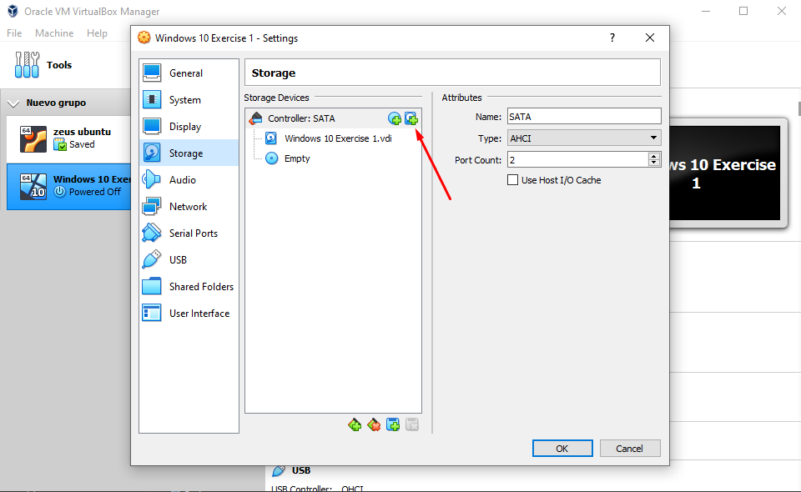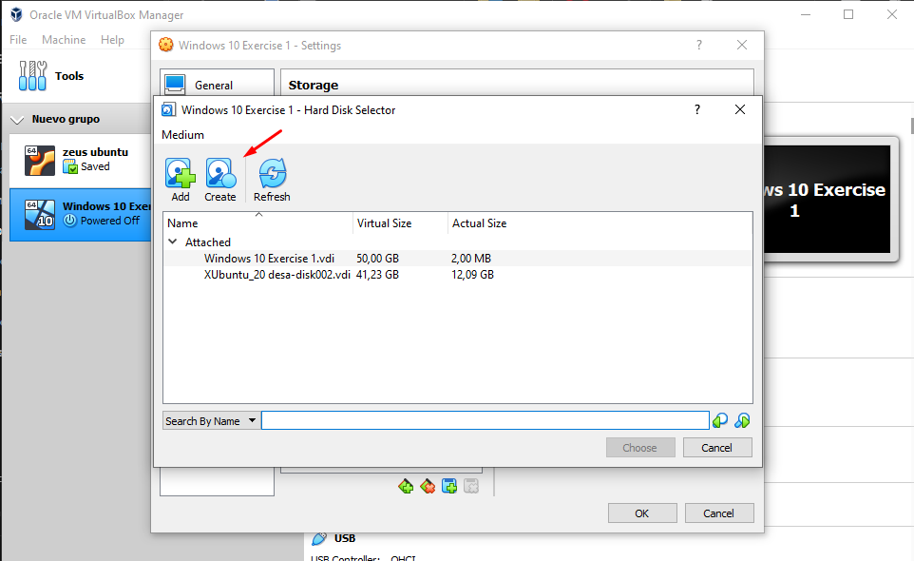.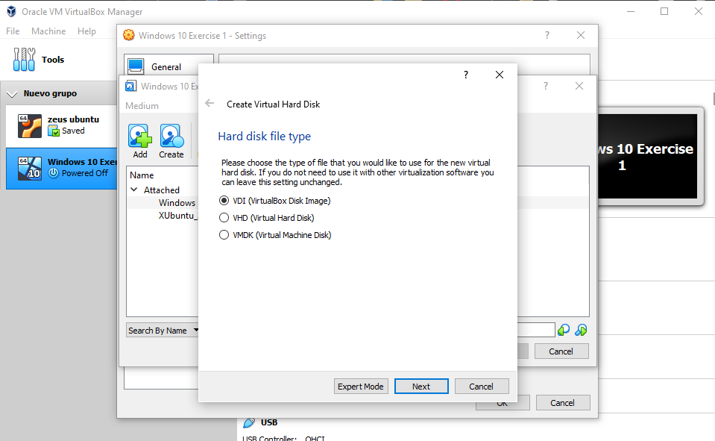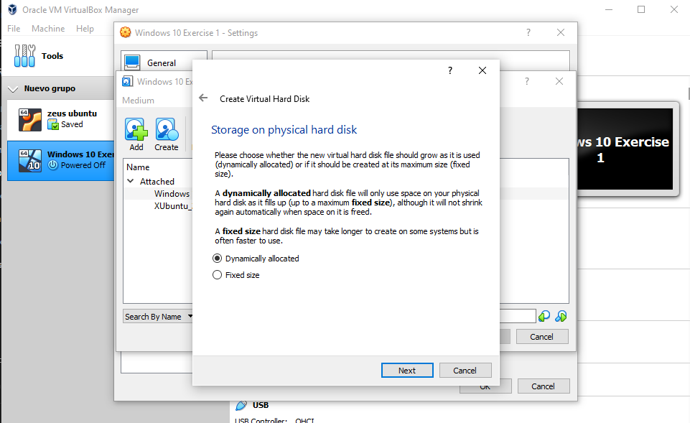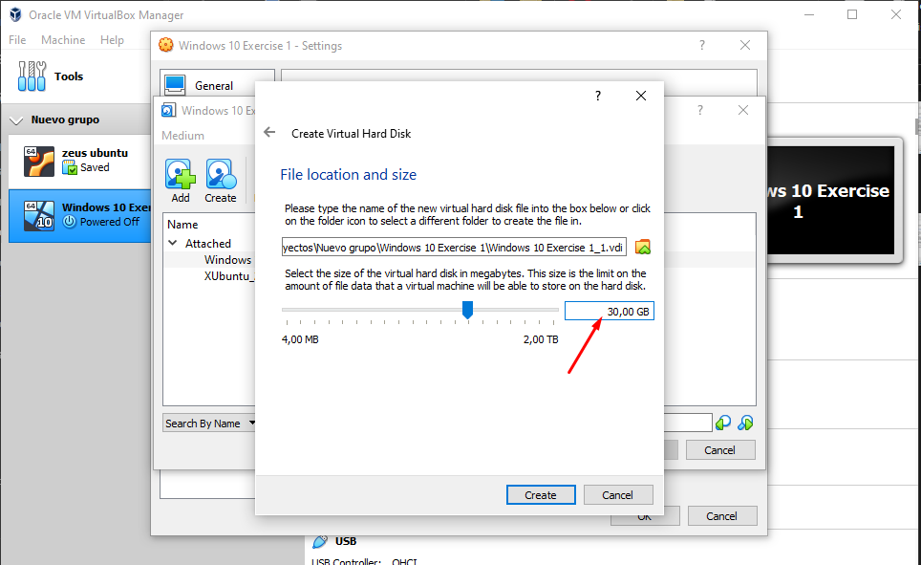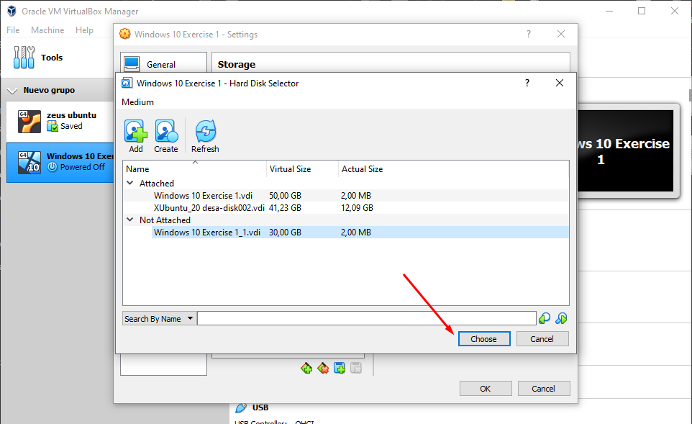

Now you have your virtual machine ready to be used!

ALFREDO PUERTA GALLEGO - DW1E

